**Video Player Documentation**

**Files:** myAnnotate.html

This file contains the skeleton of the application. This is where the video player is created as well as the box and button that allows the user to create labels and annotations.

Lines 13 – 23 Create the structure for the create new annotation button and box

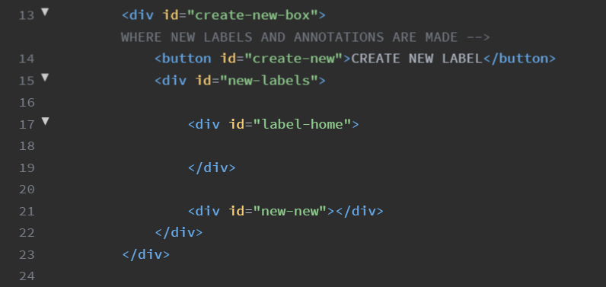

Lines 25 – 50 Contain structure for the video player an controls

Video player 25 - 29

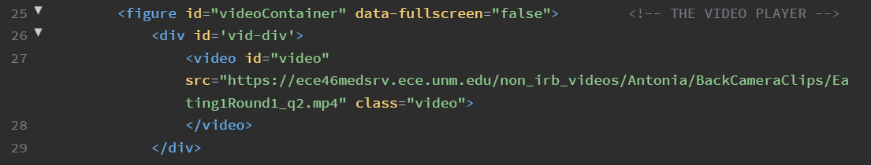

Controls 30 – 50

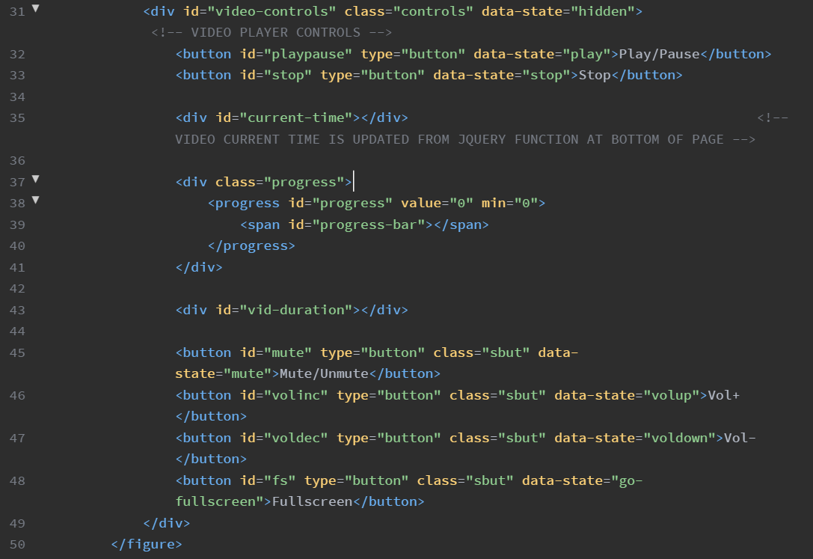

Lines 51 – 53

Print annotation buttons

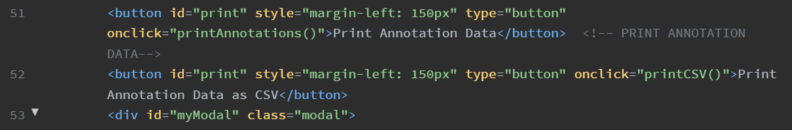

Lines 63 – 70

Required scripts:

* Firebase scripts
* The script2.js is the main javascript functionality for front end
* Jquery script

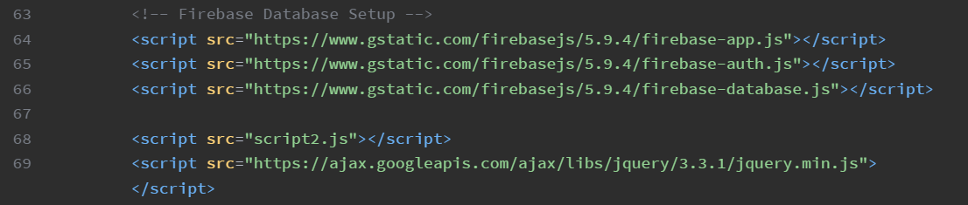

Lines 71 – 93

JQuery functions to show video duration and video current time counter

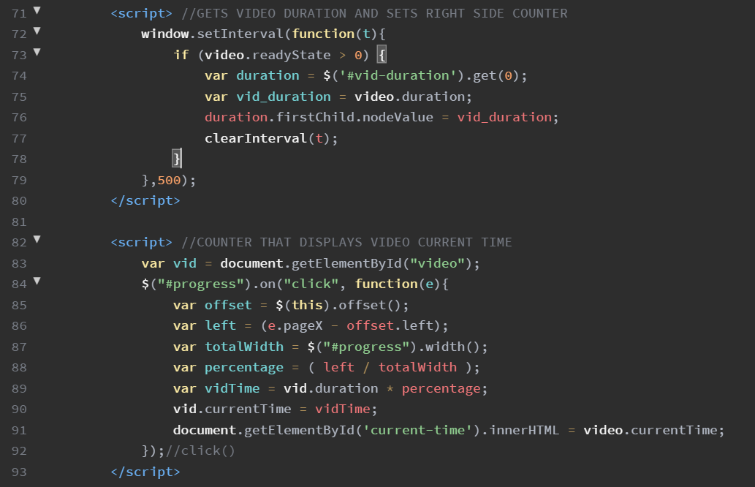

The location affected by the above JQuery functions are the counters on either side of the video progress bar as you can see in the image below.

